**/describe**

1️. a woman working in front of lighting, in the style of filmic, dark orange and gold, camera tossing, folkloric themes, campcore, dansaekhwa, rtx --ar 4:3

2️. movie making what is the importance of lighting of film, in the style of bengal school of art, light navy and orange, candid photojournalism, dogon art, vibrant stage backdrops, dslr camera, mamiya rb67 --ar 4:3

3️. women are working at the scene of the crime and lighting the scene for a film, in the style of dark orange and dark indigo, sony fe 12-24mm f/2.8 gm, indian pop culture, minimalist stage designs, ricoh gr iii, webcam, photo taken with nikon d750 --ar 4:3

4️. young female production team standing among lighting lamps, in the style of traditional techniques reimagined, saurabh jethani, capturing moments, dark purple and orange, focus on joints/connections, captivating documentary photos, ue5 --ar 4:3  
  
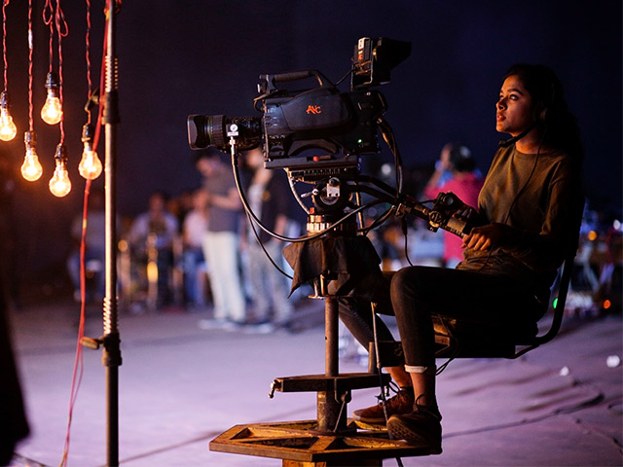

1️. a couple on the deck of the titanic at sunset, in the style of sheet film, dark red and sky-blue, emotional gestures, exaggerated poses, hyper-realistic water, film/video, carcore --ar 312:181

2️. titanic the movie, in the style of dark amber and sky-blue, celebrity photography, pre-raphaelites, light red and dark gray, quadratura, dynamic pose, romantic atmosphere --ar 312:181

3️. titanic dp_recordings manwomandogcatboat, in the style of emotionally complex, pop-culture-infused, romantic depictions of historical events --ar 312:181

4️. film titanic titanic 1985 1996 , in the style of dark amber and sky-blue, romantic atmosphere, spontaneous gestures, dignified poses, tonalist paintings, rubén maya, lightbox --ar 312:181  
  
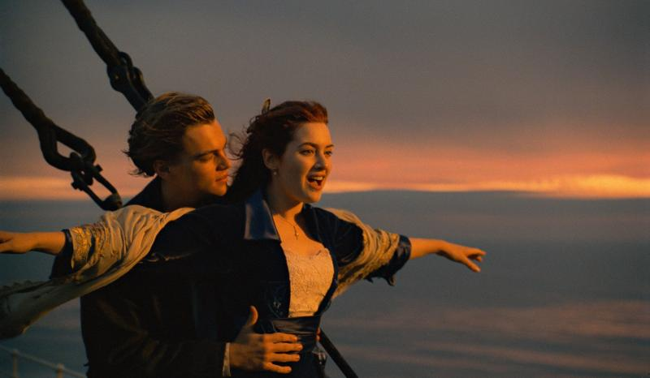

1️. a couple on the deck of the titanic at sunset, in the style of sheet film, dark red and sky-blue, emotional gestures, exaggerated poses, hyper-realistic water, film/video, carcore --ar 312:181

2️. titanic the movie, in the style of dark amber and sky-blue, celebrity photography, pre-raphaelites, light red and dark gray, quadratura, dynamic pose, romantic atmosphere --ar 312:181

3️. titanic dp_recordings manwomandogcatboat, in the style of emotionally complex, pop-culture-infused, romantic depictions of historical events --ar 312:181

4. film titanic titanic 1985 1996 , in the style of dark amber and sky-blue, romantic atmosphere, spontaneous gestures, dignified poses, tonalist paintings, rubén maya, lightbox --ar 312:181

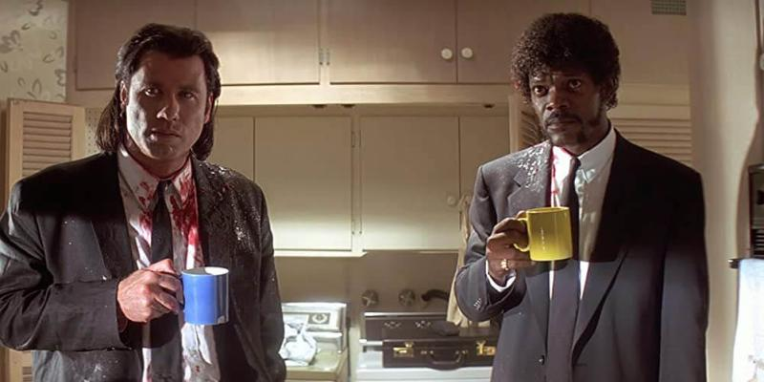

1️. the shining image: flickr, in the style of gothcore, lively facial expressions, richard bergh, giorgio vasari, sharp focus, cottagecore, extreme angle --ar 79:56

2️. the shining best moments, in the style of gothcore, neo-plasticist, jake wood-evans, associated press photo, joyful chaos, close up, cottagecore --ar 79:56

3️. the shining r rar, in the style of intense emotional expression, associated press photo, close up, exuberant, cottagecore, 1990s, 8k --ar 79:56

4️. john watson as elvis in the shining, in the style of emphasizes emotion over realism, 32k uhd --ar 79:56

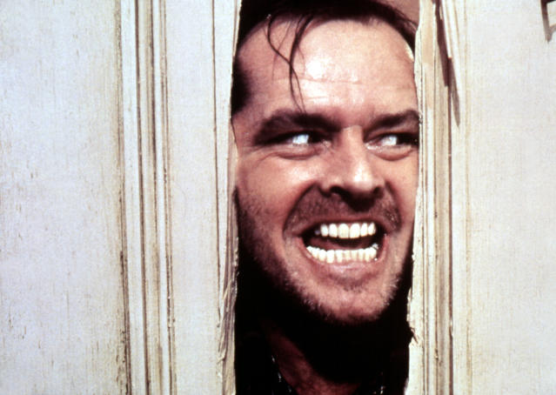

1️. the pair in yellow dress sway as night falls, in the style of gravity-free scenes, dotted, brightly colored, cyan, movie still, panorama, light-filled scenes --ar 87:65

2️. two people dancing on the street at night, in the style of romantic drama, donald pass, yellow and aquamarine, zack snyder, nature's wonder, uhd image, walt kelly --ar 87:65

3️. this beautiful couple is dancing at sunset, in the style of snapshots of iconic hollywood stars, mcdonaldpunk, movie still, colorized, romantic drama, panorama, whistlerian --ar 87:65

4️. man and woman do dance moves in a hallway, in the style of yellow and aquamarine, celebrity and pop culture references, woven/perforated, romantic landscape vistas, movie still, eye-catching, large-scale --ar 87:65

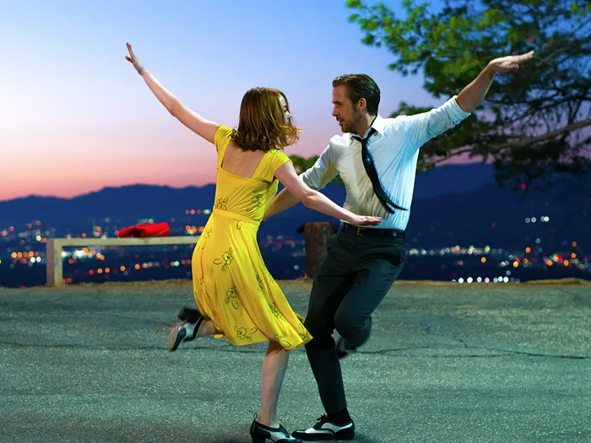

1️. marilyn monroe catches the crowd's attention in classic tv movie, in the style of magenta and bronze, modern jewelry, provia film, flickr, vibrant stage backdrops, john duncan, blink-and-you-miss-it detail --ar 9:5

2️. marilyn monroe is surrounded by many people in a tuxedo, in the style of dark pink and light gold, modern jewelry, provia film, gemstone, joyful, dark orange and silver, ferrania p30 --ar 9:5

3️. marilyn monroe surrounded by other people during a film, in the style of dark pink and light gold, modern jewelry, gemstone, joyful, performance, sterling silver highlights, orange and black --ar 9:5

4️. marilyn monroe in a dress, in the style of provia film, vibrant colorist, pink and crimson, modern jewelry, emmy bridgwater, gemstone, animated gifs --ar 9:5

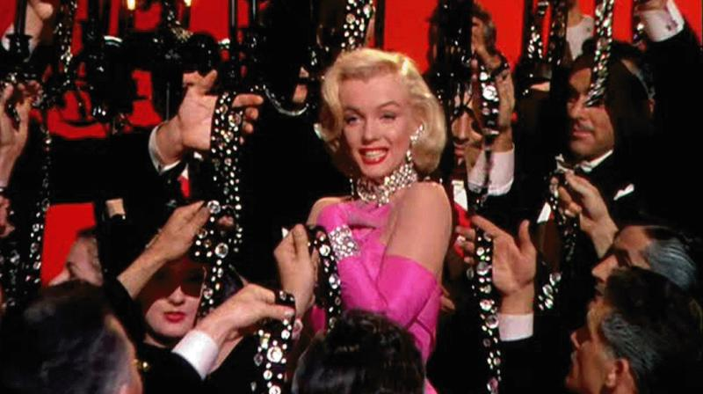

1️. in the picture a man and a woman sitting on a park bench, in the style of iconic pop culture references, light brown and pink, monumental ensembles, sheet film, white, iconic, feminine grace --ar 35:22

2️. two people sitting on a bench next to each other, in the style of drew struzan, light pink and white, firmin baes, monumental ensembles, #film, studyplace, allen williams --ar 35:22

3️. a man and woman sitting on a bench and holding a phone, in the style of iconic pop culture references, light brown and pink, monumental ensembles, i can't believe how beautiful this is, sheet film, ferrania p30, feminine grace --ar 35:22

4️. a woman sitting in a park with a man, in the style of iconic pop culture references, light brown and pink, elegantly formal, emotionally charged, zany, stylish costume design, white --ar 35:22

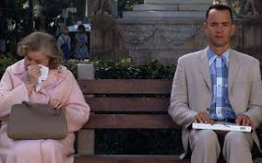

1️. a girl does some dancing in black, in the style of international gothic, sana takeda, movie still, dark white and aquamarine, rupert bunny, terrorwave, jagged edges --ar 41:23

2️. the girl is dancing amongst crowds, in the style of gothic references, gritty elegance, cryptid academia, film noir aesthetic, asian-inspired, light black and blue, intense gaze --ar 41:23

3️. lindsay troughton dancer i feel like i am at a party, in the style of gothic dark and moody, cinematic stills, asian-inspired, close up, dark white and light blue, sovietwave, sony alpha a7 iii --ar 41:23

4️. a tall blonde woman dances in front of a group, in the style of gothic dark and moody, he jiaying, rebecca sugar, fairy academia, movie still, dark white and dark aquamarine, daniela uhlig --ar 41:23

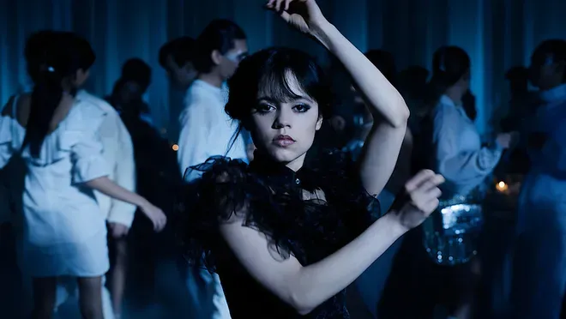

1️. an animated character is eating at a table with wine, in the style of realistic and hyper-detailed renderings, elegant, emotive faces, movie still, light navy, les nabis, high resolution, synchromism --ar 25:14

2️. a movie table with an animated guy sitting at the table, in the style of ferdinand keller, unpretentious elegance, alex gross, rendered in maya, intense close-ups, light maroon and navy, disney animation --ar 25:14

3️. a man sits down for dinner with a bottle of wine, in the style of disney animation, philip mckay, detailed character expressions, dark navy and light maroon, félix labisse, jean fouquet, sheet film --ar 25:14

4️. a man and woman are sitting at a table with a bottle of wine, in the style of disney animation, rendered in cinema4d, tokina opera 50mm f/1.4 ff, punctuated caricature, light maroon and navy, i can't believe how beautiful this is, bulbous --ar 25:14

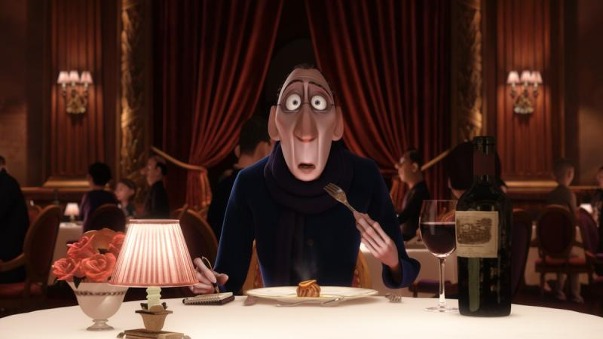

1️. a rat sits in a copper pot full of soup, in the style of disney animation, spontaneous gestures, uniformly staged images, movie still, light gray and dark blue, glazed surfaces, made of vines --ar 15:7

2️. rat on a pot of vegetable soup, in the style of movie still, sleek metallic finish, animated gifs, uniformly staged images, basil gogos, joseba elorza, glazed surfaces --ar 15:7

3️. rat in pot holding parsley, in the style of movie still, animated gifs --ar 15:7

4️. a picture of a mouse in a pot sitting on top of an oven, in the style of movie still, spontaneous gestures, animated gifs, alla prima, high resolution, made of vines, grit and grain --ar 15:7

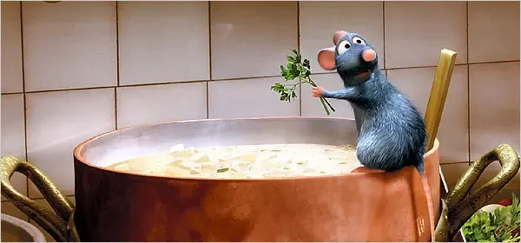

1. the anime movie kung pao panda, in the style of brushwork mastery, rtx, careful framing, #vfxfriday, celebrity and pop culture references --ar 111:64

2️. kung panda is a cat who eats food, in the style of official art, action-packed cartoons, framing --ar 111:64

3️. kung panda movie wallpaper in a red scene, in the style of thomas nast, illustrative, hyper-realistic animal illustrations, official art --ar 111:64

4️. kung panda in kushiro 2009, in the style of seth macfarlane, drew struzan, official art --ar 111:64

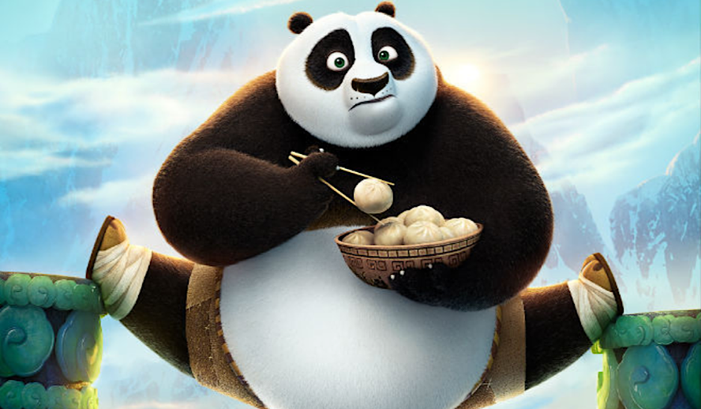

1️. the three men in the spider man suits are talking to each other, in the style of daz3d, jon foster, lively action poses, rubén maya, wimmelbilder, symmetrical, character caricatures --ar 5:4

2️. three spider man suit actors standing together, in the style of daz3d, rubens, emphasizes emotion over realism, charming realism, movie still, nostalgiacore, commission for --ar 5:4

3️. 3d modeling spider man and antman, in the style of celebrity portraits with personality, daz3d, 19th century, lively group compositions, movie still, loose gestures, symmetrical --ar 5:4

4️. a small time series of videos showing spider man's interactions with spiderman, in the style of tom bagshaw, emotive body language, steve henderson, 8k 3d, isolated figures, group zero, photo taken with nikon d750 --ar 5:4

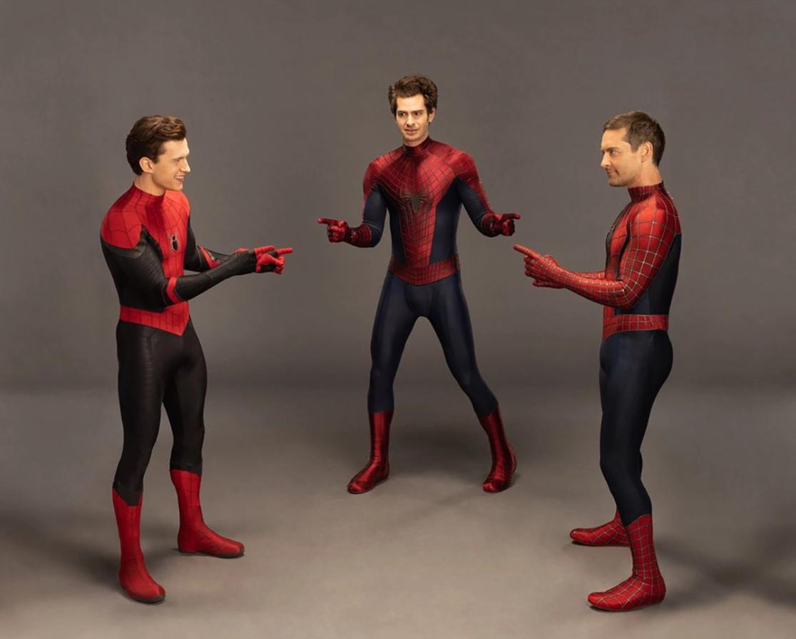

1️. tamil actor is with a big rock, in the style of mythological imagery, light white and dark gray, trashcore, mist, historically accurate, cut/ripped, photobashing --ar 106:103

2️. the man is carrying an iron wheel over his shoulder while standing next to a waterfall, in the style of mythology-inspired, thechamba, movie still, photobashing, gigantic scale, dark white and light navy, strong facial expression --ar 106:103

3️. an image of a man carrying a giant stone, in the style of cinematic sets, thechamba, i can't believe how beautiful this is, stark visuals, prateep kochabua, thomas sully, mist --ar 106:103

4️. the guy with the black belt on his head is carrying a large cuff, in the style of epic fantasy scenes, indian pop culture, 32k uhd, majestic, sweeping seascapes, stone sculptures --ar 106:103

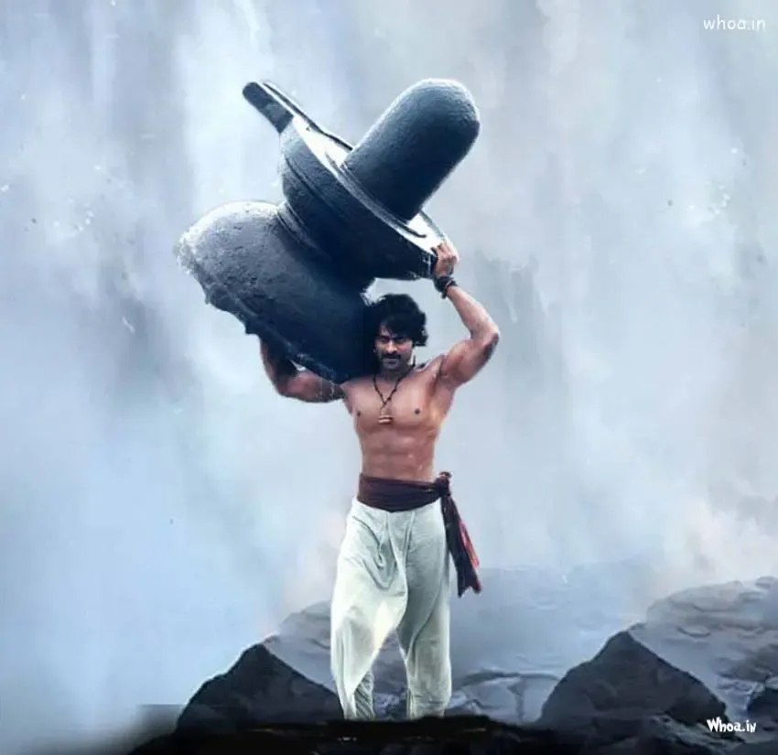

1️. a scene from a movie with 2 men on a motorcycle, in the style of light indigo and light brown, thechamba, uniformly staged images, packed with hidden details, joyful, solarization effect, soft lighting --ar 141:212

2️. two men are riding down a street on a motorcycle, in the style of indian pop culture, light emerald and light brown, movie still, classical portraiture, kerem beyit, smilecore, iso 200 --ar 141:212

3️. the two men riding on bikes against a backdrop of city on motorcycles, in the style of light emerald and light brown, candid celebrity shots, movie still, samikshavad, smilecore, folkloric portraits, high resolution --ar 141:212

4️. kartik sitara film in trailer release, in the style of multiple exposure, nikon d850, subtle, earthy tones, lively action poses, solarization effect, traditional craftsmanship, high-angle --ar 141:212

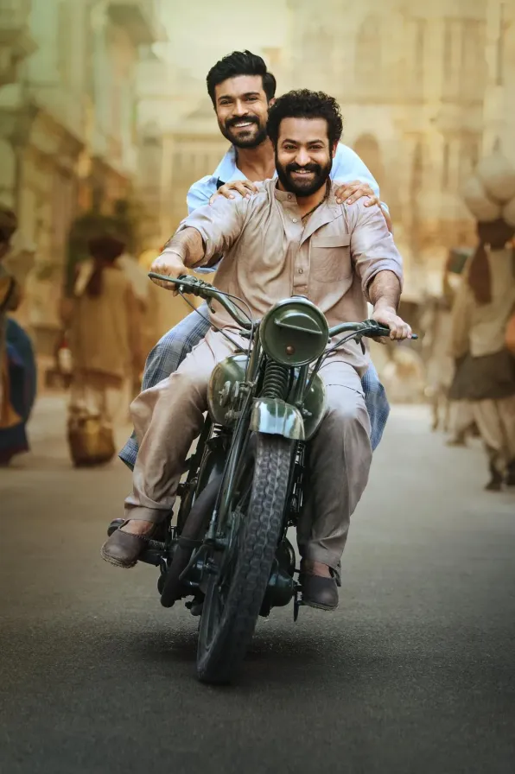

1. a man showing his oscar for something, in the style of aurorapunk, candid celebrity shots --ar 160:133

2️. a man is holding up a oscar statue holding a hand out, in the style of russell dongjun lu, candid celebrity shots --ar 160:133

3️. a smiling man with sunglasses holding a statue in his hands, in the style of maya lin, glamorous hollywood portraits, oshare kei, award-winning, film stills, siya oum, associated press photo --ar 160:133

4️. amnesiac ronaldo film award 2018, in the style of mori kei, associated press photo, theatrical gestures, olympus xa, dark white and gold, disney animation, studio portrait --ar 160:133

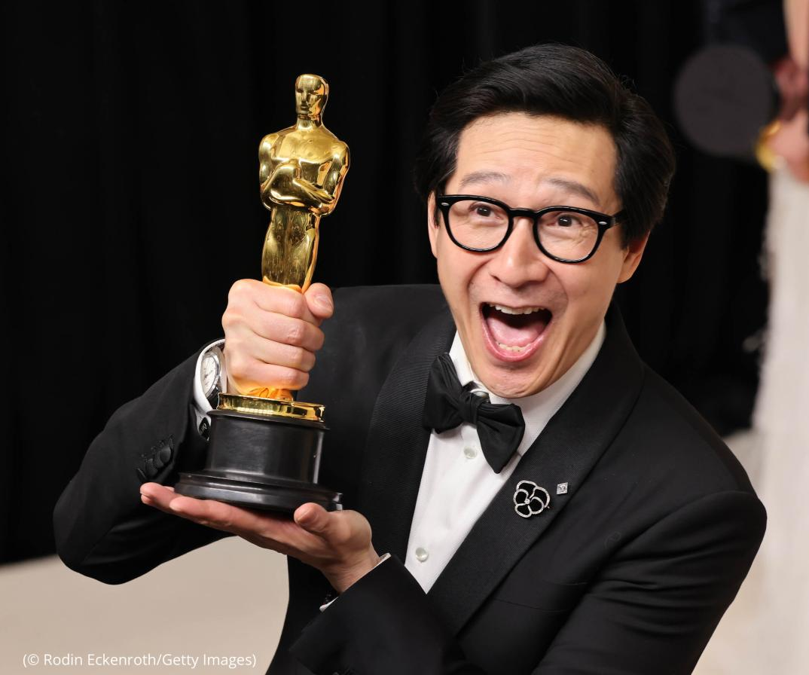

1️. scarlett johansson attends the cannes film festival, in the style of dark orange and light magenta, dslr camera, striped arrangements, pop art boldness, crisp and clean look, light brown and light black, dark green and sky-blue --ar 25:13

2️. person on the red carpet at the 2015 cannes film festival, in the style of bold curves, light orange and dark magenta, mandy disher, polka dots, camera lucida, associated press photo, spontaneous gestures --ar 25:13

3️. scarlett jones person with black shirt, grey skirt, and sunglasses at cannes film festival, in the style of light orange and magenta, mandy disher, dslr camera, snapshots of iconic hollywood stars, color stripes, 20 megapixels, emphasis on facial expression --ar 25:13

4️. scarfata person poses for the cameras, in the style of snapshots of iconic hollywood stars, whiplash curves, light orange and dark magenta, associated press photo, post-impressionism, light emerald and light beige, made of insects --ar 25:13

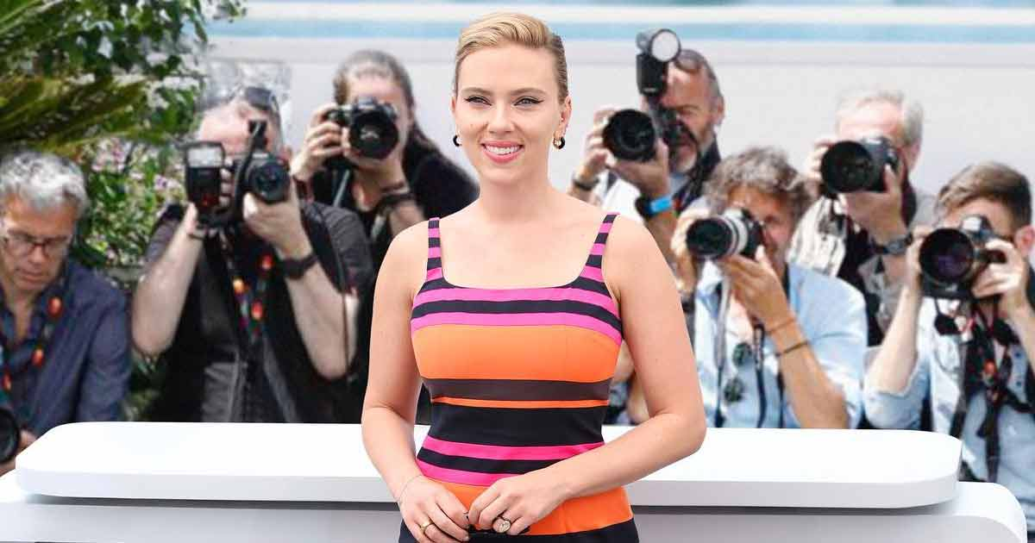

1️. a green screen and actors and women in it, in the style of light emerald, byzantine gold leaf accents, rtx on, eve ventrue, 32k uhd, hans zatzka, miniaturecore --ar 16:9

2️. dc film studios green screen, in the style of pre-raphaelite, light emerald and pink, realism with fantasy elements, miniaturecore, gigantic scale, fujifilm velvia, byzantine-inspired --ar 16:9

3️. a man and woman in front of a green screen in a movie studio, in the style of mythological scenes, pink and emerald, school of london, highly realistic, byzantine-inspired, multiple flash, dreamlike scenarios --ar 16:9

4️. a green screen set with people, in the style of pre-raphaelite, eve ventrue, tatiana suarez, ilford sfx, guo pei, miniaturecore, 32k uhd --ar 16:9

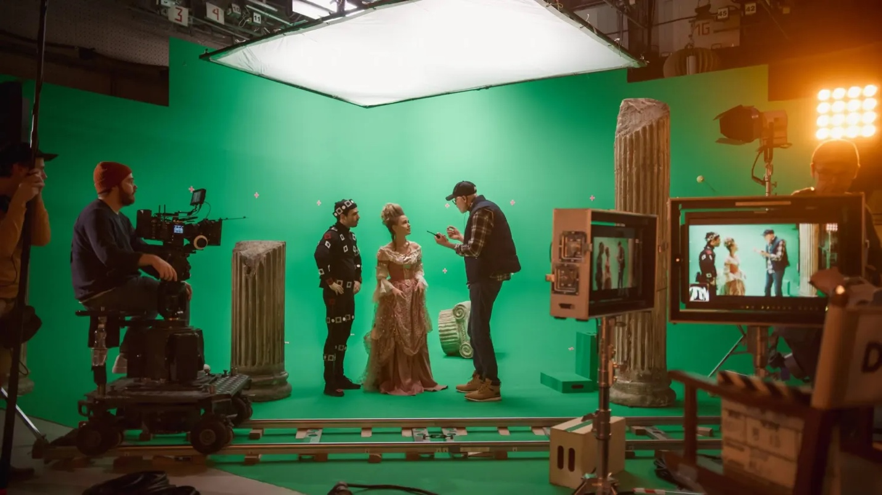

1️. three men fighting with swords in a room, in the style of sci-fi inspired futurism, light yellow and gold, low speed film, blink-and-you-miss-it detail, infinity nets, eastern and western fusion, animated gifs --ar 3:2

2️. a man and a woman in a movie room fighting, in the style of grant morrison, light yellow and bronze, infinity nets, spectacular show of ages, furaffinity, he jiaying, close up --ar 3:2

3️. the golden pheonix one man kicking two men, in the style of cinematic atmosphere, infinity nets --ar 3:2

4️. the master film 2 black hat, in the style of light and space movement, manticore, action-packed scenes, precisionist, yellow and brown, human connections, cinematic stills --ar 3:2

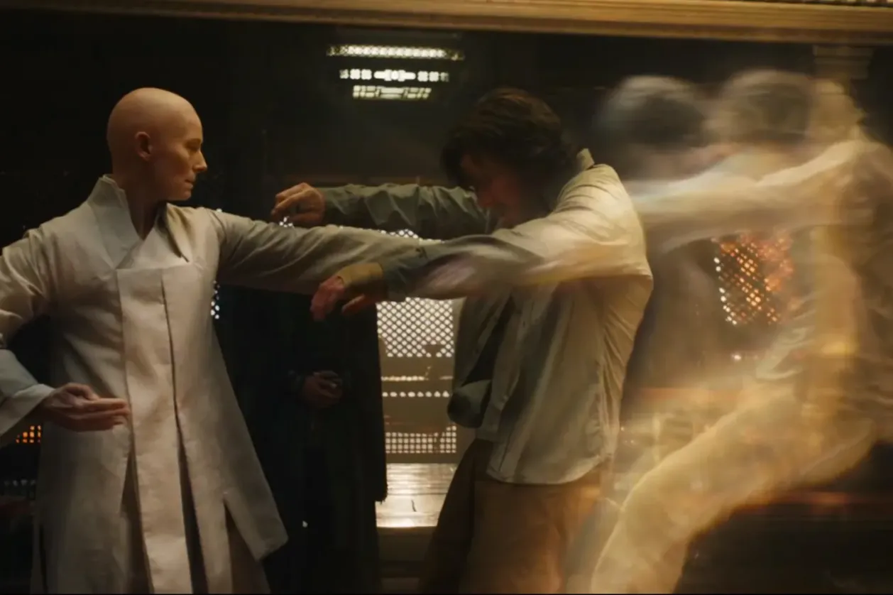

1️. pakkadali ''ekdaali'' video song songs, song titles, in the style of movie still, fatima ronquillo, romantic and nostalgic themes, sky-blue and red, folk/naïve:, photo taken with provia, award-winning --ar 103:68

2️. two young actors sit on rocks while looking at water, in the style of thota vaikuntam, romantic and nostalgic themes, red and blue, movie still, light green and red, splattered paint, intricate lines --ar 103:68

3️. two people in colorful sitting on top of rocks next to a river, in the style of bengal school of art, romantic drama, movie still, light green and red, detailed facial features, sheet film, delicate and intricate details --ar 103:68

4️. a young couple sitting on a large rock, in the style of indian pop culture, crimson and blue, red and green, sheet film, intricate detailing, youthful protagonists, junglecore --ar 103:68

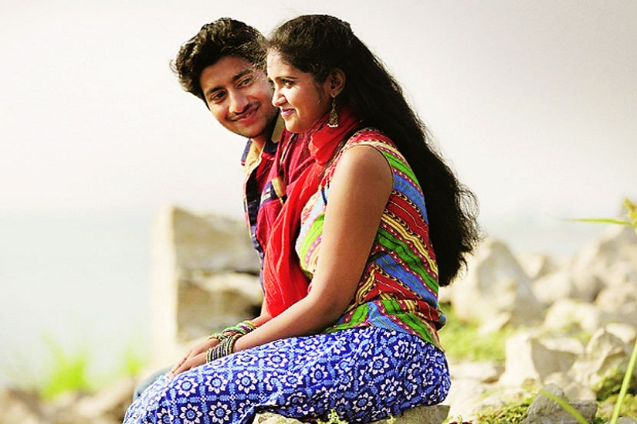

1️. one of the men walking in the ocean with a spaceship next to it, in the style of imax, dark white and beige, sheet film, rtx on, uniformly staged images, realistic lifelike figures, grid --ar 120:67

2️. the martian' with man in space suits walking in the ocean, in the style of photo-realistic landscapes, white and navy, aftereffects, uniformly staged images, hyper-realistic water --ar 120:67

3️. an astronaut and a couple of other men standing by a boat in the water, in the style of matte painting, crumpled, creased, movie poster, light white and light navy, sharp attention to detail, grid --ar 120:67

4️. the martian is a science fiction film directed by sam heughan and jon huntsman, in the style of coastal scenery, david yarrow, igor morski, navy and beige, stylish costume design, cinestill 50d, large-scale photography --ar 120:67

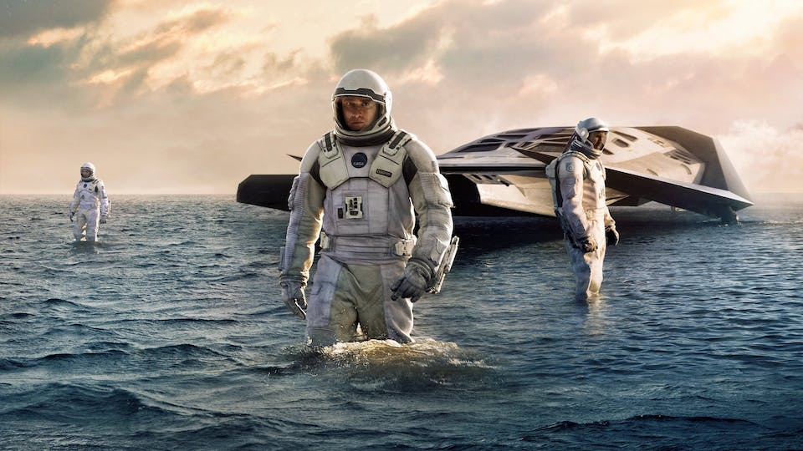

1️. a train of soldiers riding together on the ship, in the style of roger deakins, chris riddell, meryl mcmaster, large format film, vibrant stage backdrops, anglocore, dynamic and action-packed --ar 500:281

2️. a large group of men have helmets and are standing on a watercraft, in the style of motion picture film, war scenes, soft atmospheric perspective, striped arrangements, pre-raphaelitism, rtx on, blown-off-roof perspective --ar 500:281

3️. d day soldiers on a boat riding out to sea, in the style of isaac julien, chris riddell, vibrant stage backdrops, mamiya 7 ii, made of all of the above, peter sculthorpe, repetitive --ar 500:281

4️. army men crowded in vehicles on a boat, in the style of exploitation cinema, traditional british landscapes, strong emotional impact, spectacular show of ages, atmospheric installations, whistlerian, dynamic and action-packed --ar 500:281

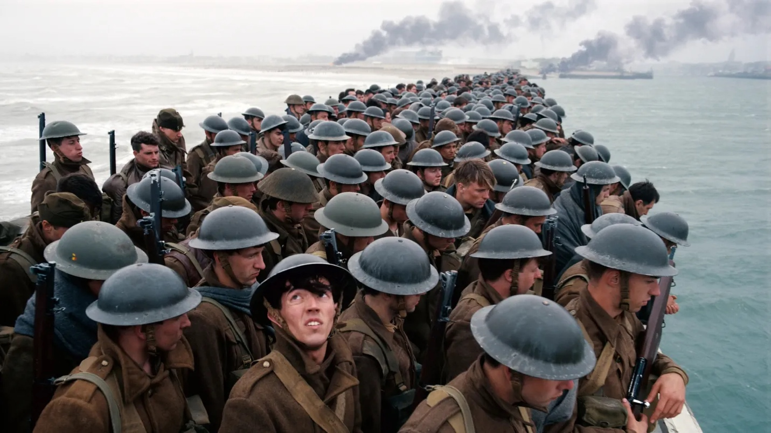

1️. a man in white shirt standing next to a whiteboard with mathematics on it, in the style of movie still, striped, i can't believe how beautiful this is --ar 128:71

2️. a man in white shirt refers to the chalkboard, in the style of movie still, calculated --ar 128:71

3️. michael caine in "the formula", in the style of mathematical precision, bill watterson, black mountain college, 3840x2160, scientific diagrams, chalk, rob liefeld --ar 128:71

4️. amy hemingway at the science teacher irvin, in the style of relatable personality, chalk, 8k resolution, gray and brown, striped arrangements, cosmic graffiti, focus on materials --ar 128:71

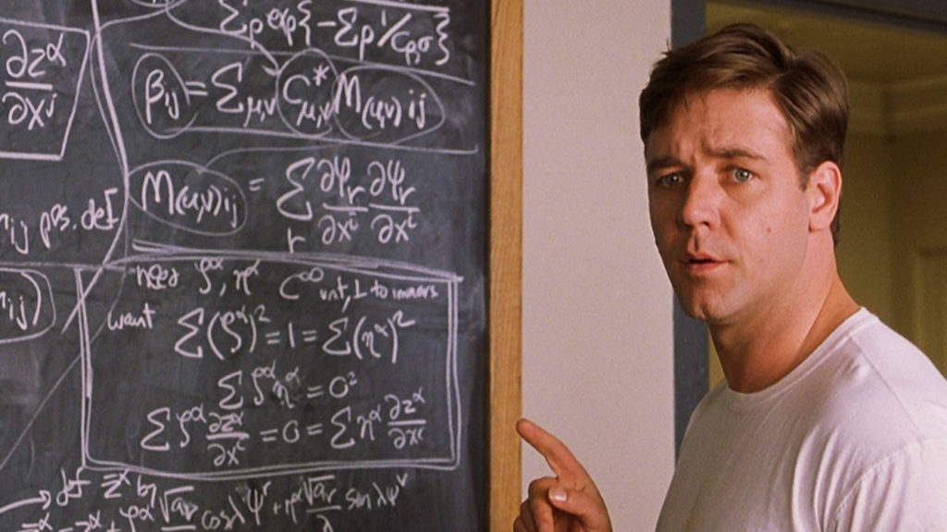

1️. Lincoln movie a man sitting in a group of soldiers in a rain storm, in the style of dark violet and dark aquamarine, realist detail, master of ink, dignified poses, creative commons attribution, stylish costume design, blink-and-you-miss-it detail --ar 128:51

2️. a black man standing with some men in front of him in a rain, in the style of transcendentalist themes, iconic american, walt disney, theatrical lighting, master of ink, pseudo-historical fiction, movie still --ar 128:51

3️. a man in a suit with other men sitting, in the style of tenebrism-inspired, iconic american, soggy, moody lighting, alex alemany, eastern and western fusion, historically accurate --ar 128:51

4️. a man stands with a group of men at a train track, in the style of intriguingly taboo, theatrical lighting, soggy, patriotic, bentwood, dark gray and light azure, monumental ensembles --ar 128:51

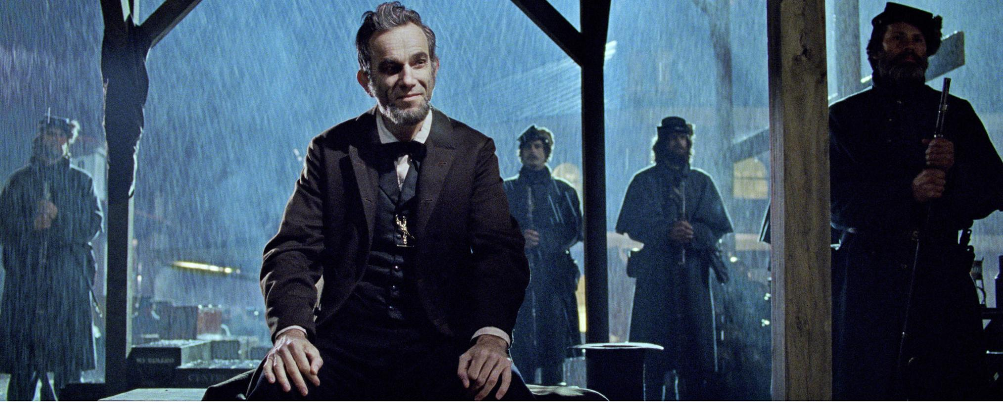

1️. the martial arts legend in a street scene, in the style of theatrical exuberance, emphasis on action --ar 20:13

2️. a man holds a sword in front of people, in the style of theatrical exuberance, asian-inspired, trashcore, classicist approach, highly staged scenes, large-scale, movie still --ar 20:13

3️. a man with sticks playing karate with others in suits, in the style of changelingcore, asian-inspired, movie still, lively street scenes, anthropological, imposing monumentality, 21st century --ar 20:13

4️. a beautiful martial artist takes a fight with other men, in the style of theatrical exuberance, russell dongjun lu, tom chambers, panchromatic film, action-packed cartoons, xu bing, large-scale --ar 20:13

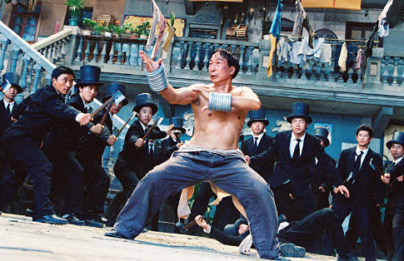

1️. a man holding a hammer while holding up his hand with black hair, in the style of mote kei, jagged edges, mamiya rb67, salon kei, confessional --ar 171:128

2️. a man on a bed holding a large hammer and knife, in the style of dolly kei, jagged edges, movie still, sharp/prickly, dark black and gold, salon kei, close-up --ar 171:128

3️. a man holding a metal hammer with hand held on it, in the style of satoshi kon, candid celebrity shots, jagged edges, he jiaying, photo taken with ektachrome, confessional, tom chambers --ar 171:128

4️. a man holds up his hammer and holding off an opening, in the style of satoshi kon, candid celebrity shots, hisui sugiura, holga 120n, jagged edges, he jiaying, intense gaze --ar 171:128

